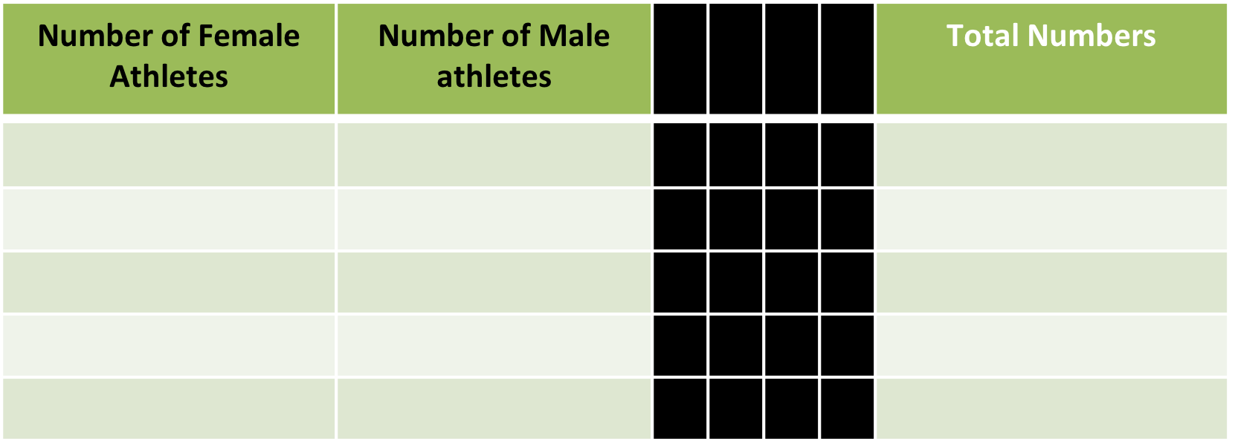

**Federation: _______________________________**

**Contact Name:______________________________**

**Contact email: ____________________________**

Please use this form to notify the Organizers of the Cancun Grand Prix the number of athletes that will be taking part of the Training Camp – June 19-21, 2017 – you may use form B to make the necessary hotel reservations ---

**CANCUN GRAND PRIX 2017, MEXICO**

*Form D*

Training Camp Registration

Please send this Form to: cancungrandprixjudo@gmail.com